Chip back potential is the level which bulk silicon is maintained by on-chip connection, or it is the level to which the chip back must be connected when specifically stated below. If no potential is given the chip back should be isolated.

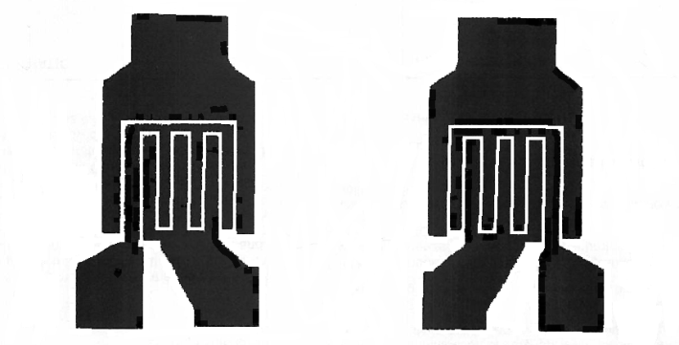
C C
B E E B
.023”
.038”

Top Material: Al
Backside Material: Au
Bond Pad Size: .004” min.
Backside Potential:
Mask Ref:

APPROVED BY: DK DIE SIZE .023” X .038” DATE: 3/3/17
MFG: LINEAR SYSTEMS THICKNESS .008” P/N: LS3250A
DG 10.1.2

Rev B, 7/19/02

